1. Home:

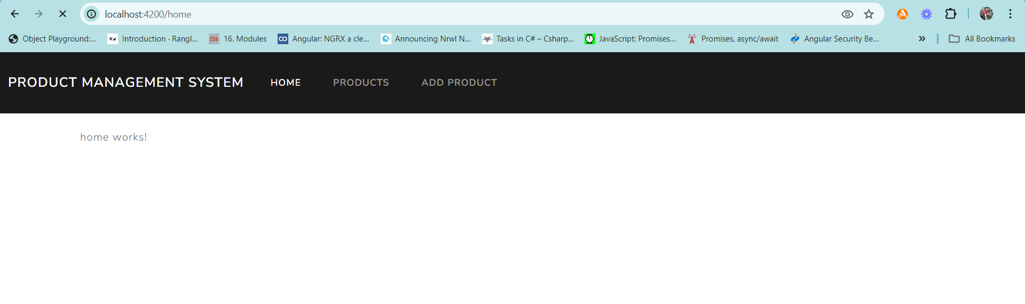

1. View all products

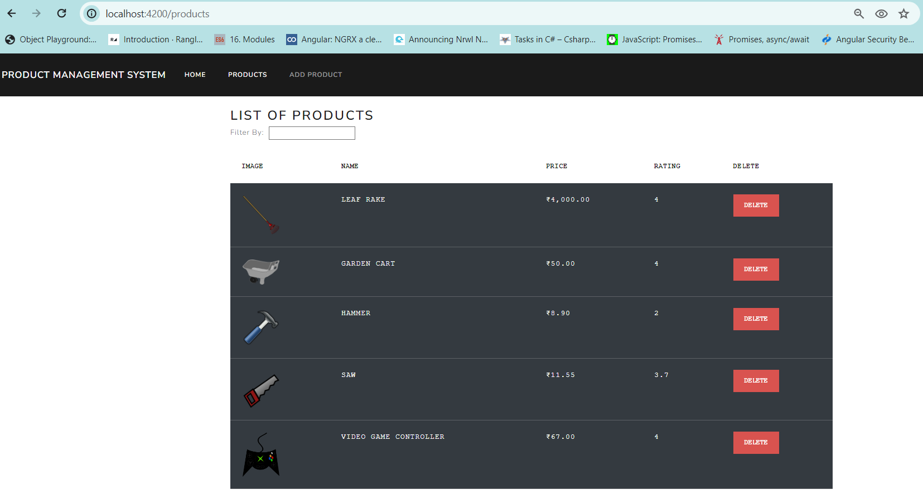

1. View a product detail [by clicking an image in any row in the products component]

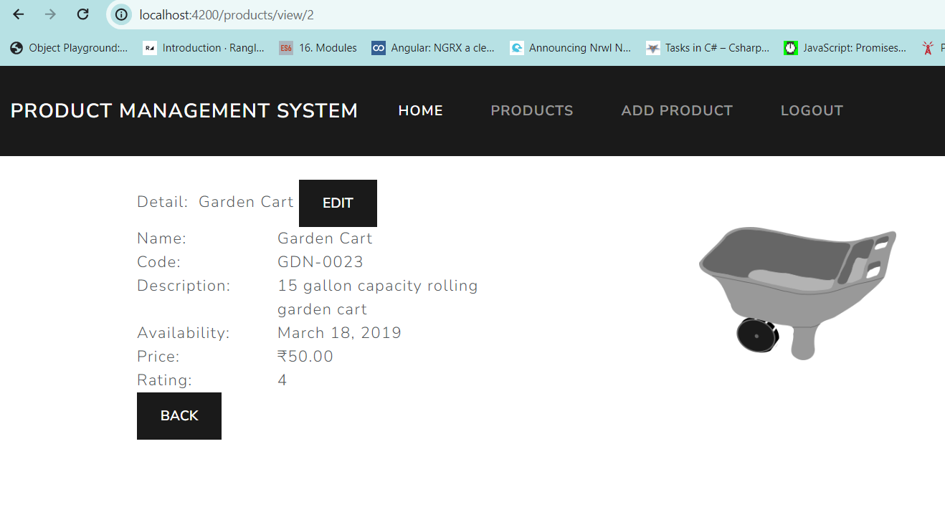

1. Update the product [on click of Edit button on view component]

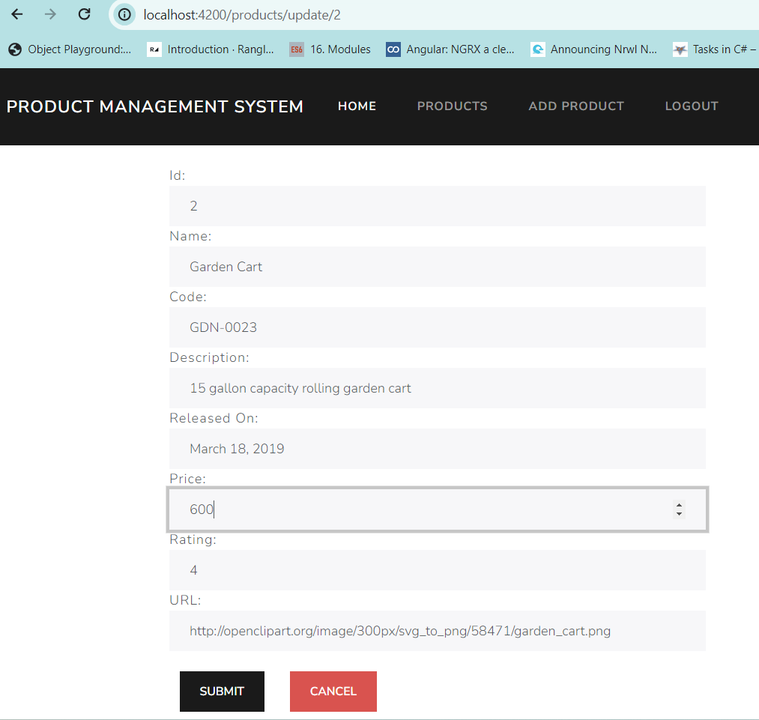

Asking for confirmation to update:

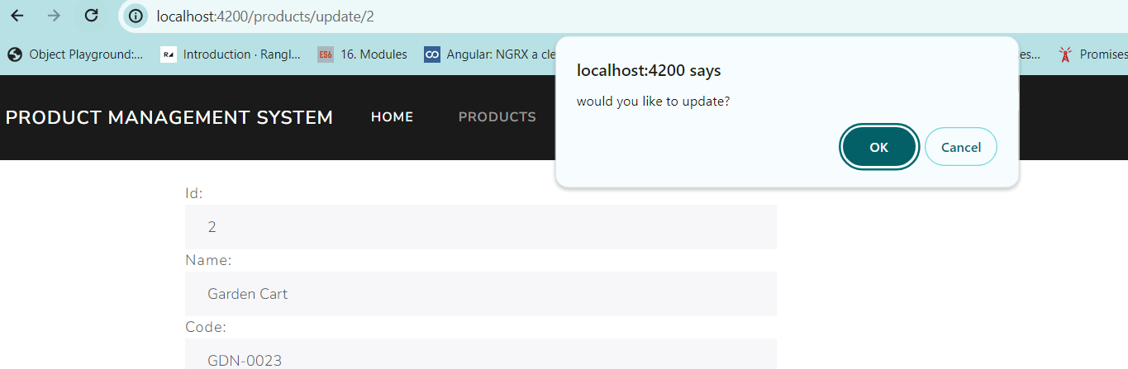

Successful update message

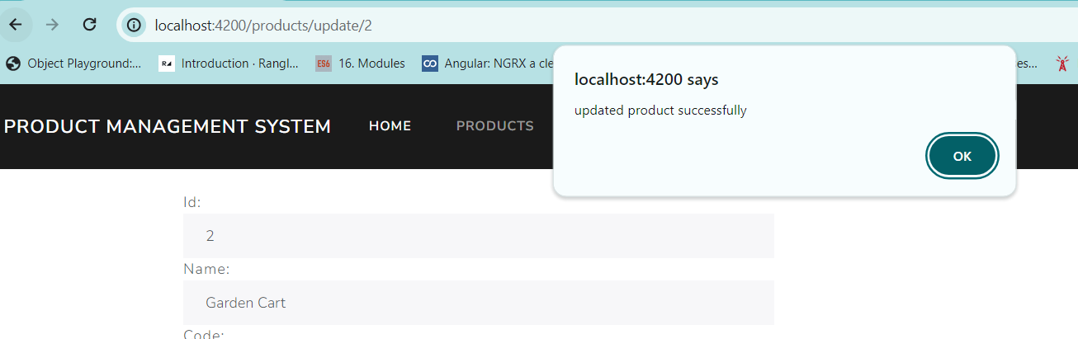

Redirection to products component

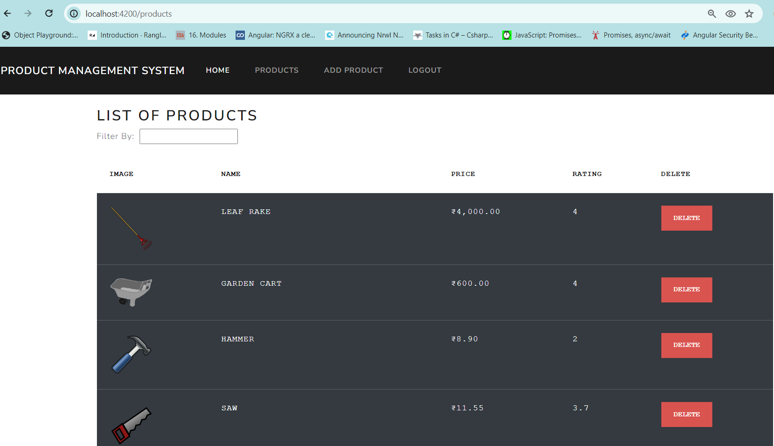

1. Add product [by clicking “Add product” menu on navigation bar]

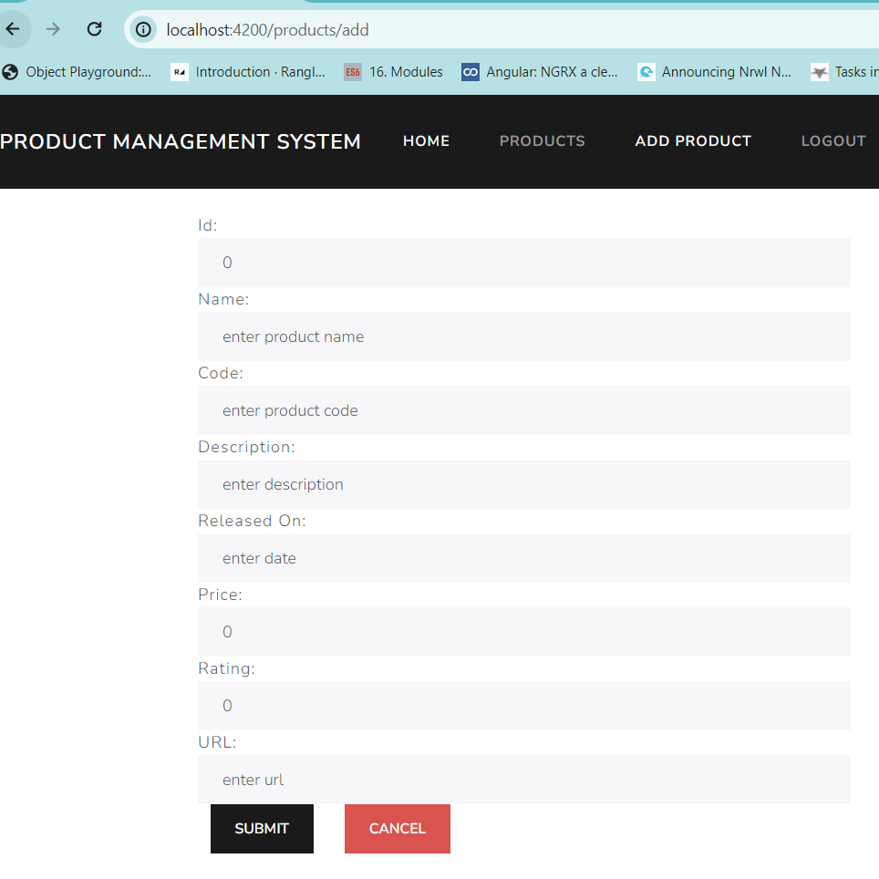

Enter product details and click on submit which should ask for confirmation:

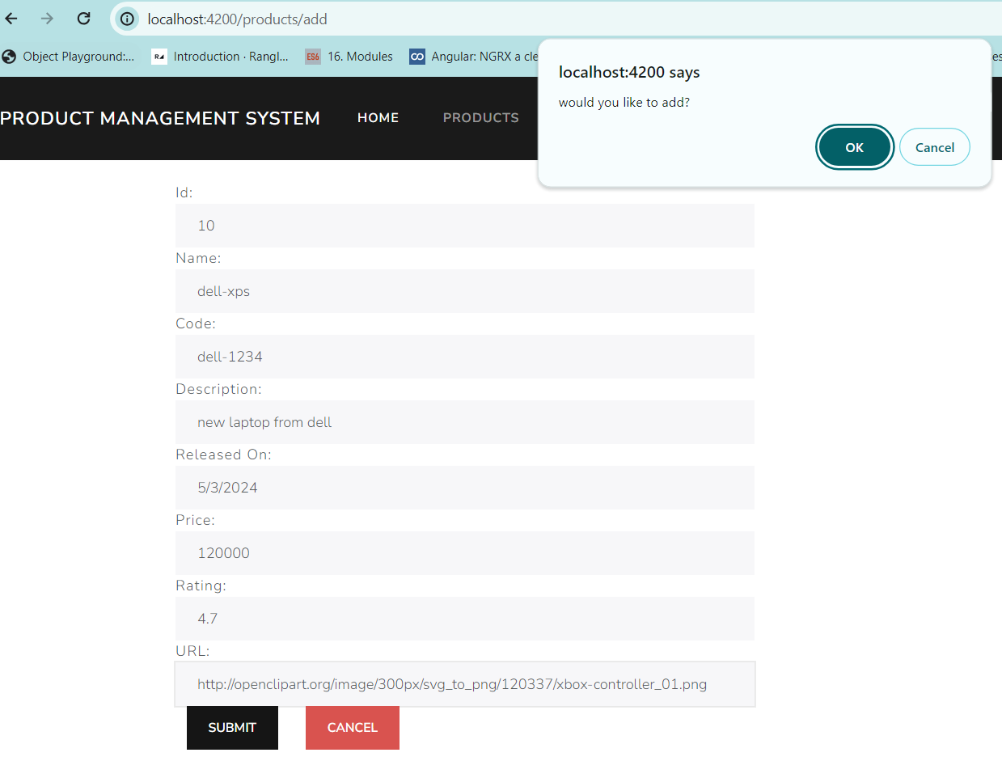

Successful addition message

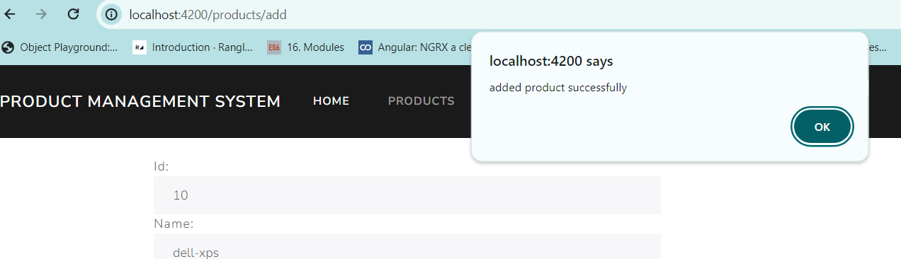

Redirection to products component

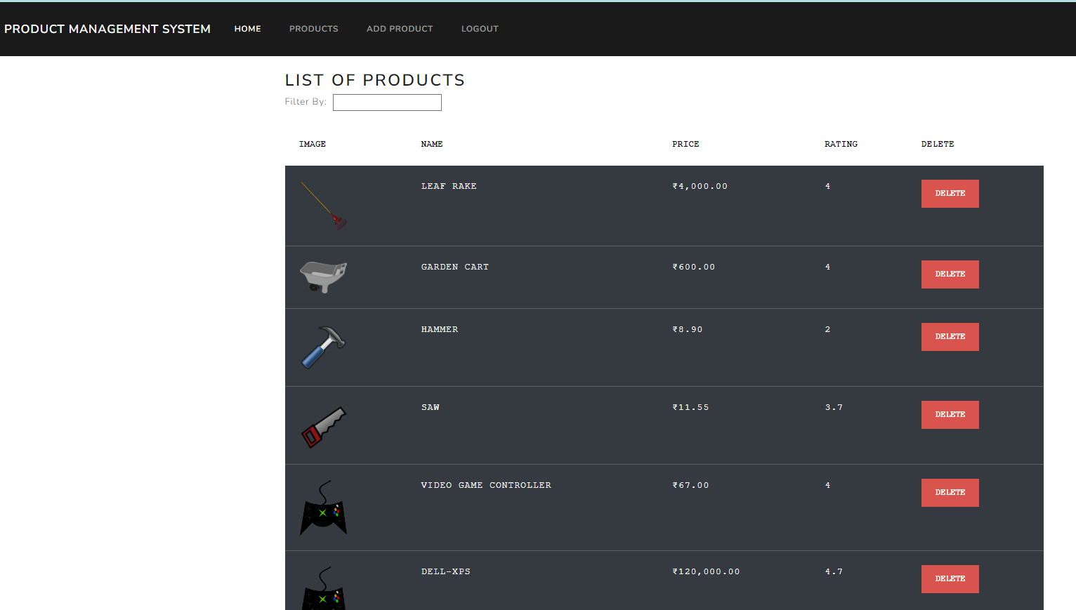

1. Click on “delete” button in any row on products component to delete a record, which will automatically reload the table. Ask for confirmation.

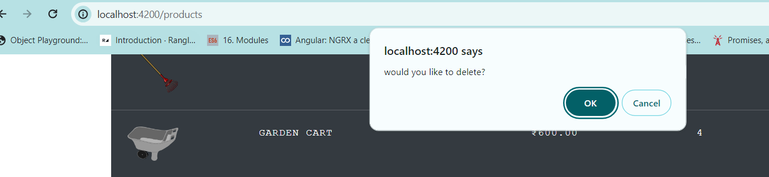

Deletion confirmation:

